## TheoryandConcept

Objective:-Toimplement theconcept ofIndexesandviews.

**Indexes-** An index is an ordered list of content of a column or group of columns in a table. An index created on the single column of the table is called simple index. When multiple table columns are included in the index it is called composite index.

CreatinganIndexforatable:-

Syntax(Simple)

CREATEINDEXindex\_name ON tablename(column name);

CompositeIndex:-

CREATEINDEXindex\_name

ONtablename(columnname,columnname); Creating an UniQuestion Index:-

CREATEUNIQUESTIONINDEXindexfilename ON tablename(columnname);

DroppingIndexes:-AnindexcanbedroppedbyusingDROP INDEX

SYNTAX:-

DROPINDEXindexfilename;

Views:-

Logicaldata is how we want to see the current data in our database. Physical data is how this data is actually placed in our database.

Viewsaremasksplacedupontables.Thisallowstheprogrammertodevelopamethodvia which we can display predetermined data to users according to our desire.

Viewsmaybecreatedforethefollowingreasons:

1. TheDBAstorestheviewsasadefinitiononly.Hencethereisnoduplicationofdata.
2. SimplifiesQueries.
3. CanbeQuestionried asabasetableitself.
4. Providesdata security.
5. Avoidsdata redundancy.

CreationofViews:-Syntax:-

CREATE VIEW viewname AS SELECTcolumnname,columnname FROM tablename

WHEREcolumnname=expression\_list;

Renaming the columnsofa view:-Syntax:-

CREATEVIEWviewnameAS SELECT newcolumnname…. FROM tablename

WHEREcolumnname=expression\_list;

Selecting a data setfroma view-Syntax:-

SELECTcolumnname,columnname FROM viewname

WHEREsearchcondition;

Destroying a view-

**Syntax:-**

DROP VIEWviewname;

## Experiment 9

Objective:AnswerthefollowingQuestions

Q1.Create an index on the table client\_master, fieldclient\_no.

C:\Users\devsr\AppData\Local\Packages\MicrosoftWindows.Client.CBS_cw5n1h2txyewy\TempState\ScreenClip\{9B87436E-A9BB-4A52-AAF1-EBEF58336132}.png

Q2.Create an index on the sales\_order, field s\_order\_no.

C:\Users\devsr\AppData\Local\Packages\MicrosoftWindows.Client.CBS_cw5n1h2txyewy\TempState\ScreenClip\{581DF95C-4FD5-42C4-8F87-FC37E01F7BDD}.png

Q3.Create an composite index on the sales\_order\_details table for the columns s\_order\_no and product\_no.

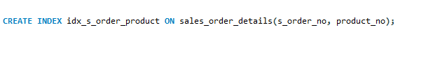

Q4.Create an composite index ch\_index on challan\_header table for the columns challan no and s\_order\_no.

C:\Users\devsr\AppData\Local\Packages\MicrosoftWindows.Client.CBS_cw5n1h2txyewy\TempState\ScreenClip\{011AFBA5-D005-497C-B3ED-61A51F4B44C0}.png

Q5.CreateanuniQuestionindexonthetablesalesman\_master,fieldsalesman\_no.

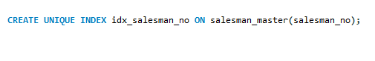

Q6.Drop index ch\_index on table challan\_header.

C:\Users\devsr\AppData\Local\Packages\MicrosoftWindows.Client.CBS_cw5n1h2txyewy\TempState\ScreenClip\{3097E03C-5EC2-41CE-BBE3-A0760F440887}.png

Q7.Create view on sales man\_master whose sal\_amtis less than3500.

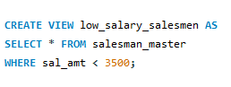

Q8.Createa viewclient\_view on client\_master and rename the columns as name, add1, add2, city, pcode, state respectively.

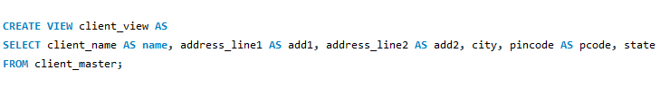

Q9. Select the client names from client\_view who lives in city ‘Bombay’.

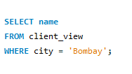

Q10. Drop the view client\_view.

C:\Users\devsr\AppData\Local\Packages\MicrosoftWindows.Client.CBS_cw5n1h2txyewy\TempState\ScreenClip\{9456E90D-7B90-44E6-A072-92818D55D88D}.png